

**Internship Letter**

Date: 6 AUG 2017

**TO WHOM IT MAY CONCERN**

This is to certify that **Uzma Ahmed** has completed 6 weeks internship as a MEAN Stack Developer , started on 20 JUN 2017.

Very truly yours,

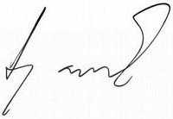

Vitarka Solutions